Reconciliation Report:
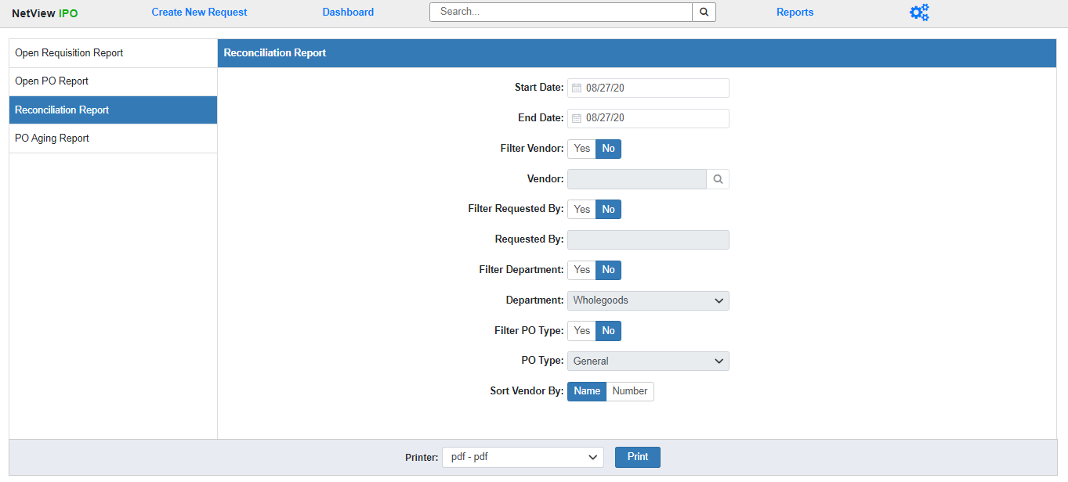
The Reconciliation Report lists all Purchase Orders with lines that have been fully reconciled to an invoice during a set time period, and records the variance between the PO amount (the amount expected to be paid) and the invoice amount (the amount actually paid). You can use the fields displayed to run the report for specific items, such as viewing all the relevant POs for a single vendor or for a specific Department.
Field Definitions:
Start/End Date: Enter the start and end dates for your desired time period. The report will include all POs that had lines reconciled during that time period (the Reconciliation Date for each line will display on the report). Both fields default to the current date.
Filter Vendor: Select Yes to run the report for all relevant POs belonging to a specific vendor. Select No to run the report for all vendors.
Vendor: This field will activate if you choose to filter the report by vendor. Enter the Vendor Number you wish to run the report for or use the Search option to look it up by entering part or all of the vendor’s name.
Filter Requested By: Select Yes to run the report for all relevant POs created by a specific user. Select No to run the report for all creation users.
Requested By: This field will activate if you choose to filter the report by the creation user. Enter the desired user’s ID here. NOTE: If the ID you enter doesn’t exist in the system, you will receive a blank report.
Filter Department: Select Yes to run the report for all relevant POs belonging to a specific Department. Select No to run the report for all Departments.
Department: This field will activate if you choose to filter the report by Department. Select the desired department from the drop-down menu. The options will be all Departments that currently exist in your system.
Filter PO Type: Select Yes to run the report for all relevant POs with a specific PO Type. Select No to run the report for all PO Types.
PO Type: This field will activate if you choose to filter the report by PO Type. Select the desired type from the drop-down menu: General, Unit, or Part.
Sort Vendor By: The report is sorted by the PO Vendor, and lists both the Vendor Name and the Vendor Number. Use this option to select if you want the report sorted by Vendor Name or Vendor Number. The report sorts by Vendor Name by default.
Printer: Select the printer to receive the report. Use the pdf printer to view the report before printing.
Click “Print” to run the report.
Sample Report:
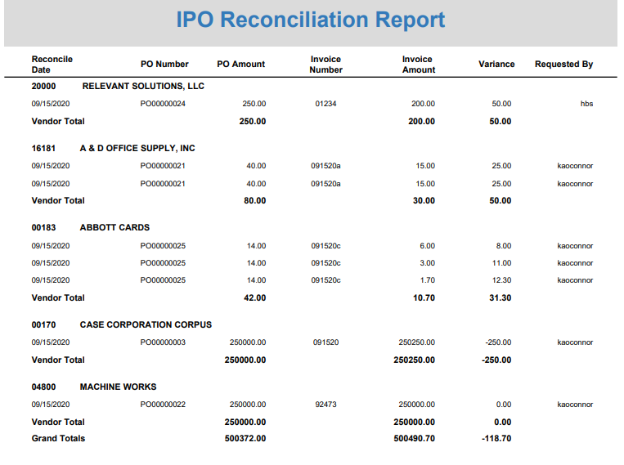
The report is divided into sections by vendor, with each section beginning with a line listing the vendor number and name. Each line represents one line item on a PO, as line items are individually reconciled.
Report Columns:
Reconcile Date: This column shows the date the line item was reconciled.
PO Number: This column shows the PO number that contains the line item.
PO Amount: This column shows the line item’s amount as listed on the PO, i.e. the amount the business expects to pay for the item.
Invoice Number: This column shows the number of the invoice the line item was reconciled against.
Invoice Amount: This column shows the amount listed for the line item on the invoice, i.e. how much the business actually paid for the item.
Variance: This column shows any variance between the PO Amount and the Invoice Amount for the line item.
Requested by: This column shows the user who originally created the document requested the line item.
Vendor Totals: A total line for each vendor appears after their last line entry. It shows the total value of the PO Amount, Invoice Amount, and Variance columns for the vendor, which can alert the business as to whether or not this particular vendor may be generally charging them more than they expect to pay.
Grand Totals: This line appears at the end of the report and provides report totals for the PO Amount, Invoice Amount, and Variance columns. This allows the business to see whether they are generally paying more or less for their orders than expected.

